|  |  |
| --- | --- |
| Name | Yash Shinde |
| NUID | 001493321 |
| Course | DWBI Online |

1.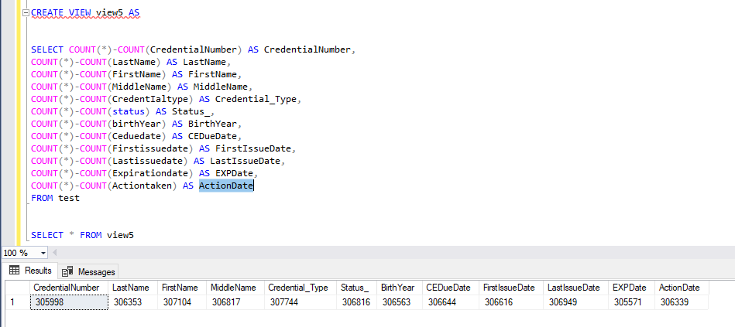

2.

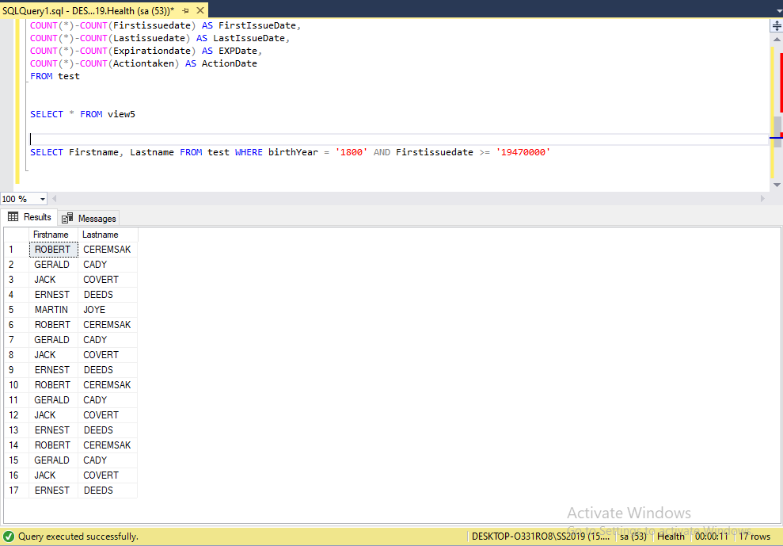

3.

